Protein Family Classification Using k-mer Frequency Features and BLAST Homology
Mohamed Karim (Reg: 221010054) · Yousef Abdallah Khamis (Reg: 221002152)
CAI4704: AI in Bioinformatics — Group 2 — Project 1
Submission Date: 22/05/2026 | GitHub: github.com/7amokarim/Protein-Family-Classification

Abstract
This report presents two approaches to automated protein family classification on a four-class UniProt Swiss-Prot dataset (Kinase, Protease, Receptor, Transporter; Homo sapiens). Student B implements k-mer frequency feature extraction with Random Forest classifiers (k=3 and k=4). Student A implements a BLAST homology-based baseline. The k-mer (k=3) + Random Forest achieves the best ML accuracy of 37.5% (macro F1 = 0.37), while the BLAST baseline achieves 93.4% accuracy on the 79.7% of test sequences with detectable homology. Results highlight that classical homology-based methods remain highly competitive and that k-mer composition provides a useful signal when homology is unavailable.
Index Terms—bioinformatics, protein family classification, k-mer features, random forest, BLAST, UniProt.

I. INTRODUCTION
Protein family classification is a fundamental challenge in computational biology. With the rapid expansion of genome sequencing, millions of newly discovered protein sequences lack functional annotation. Assigning sequences to known protein families is the critical first step toward understanding biological roles, inferring structures, and designing targeted therapeutics.
This report evaluates two complementary approaches: (1) k-mer frequency-based Random Forest classifiers (k=3 and k=4) by Student B, and (2) a BLAST homology-based baseline by Student A, applied to four human protein families: Kinases, Proteases, Transporters, and Receptors.
II. DATASET
All sequences were retrieved from UniProt Swiss-Prot (reviewed entries, Homo sapiens, 50–1,000 aa). Student B used a 200-sample test set (44 Kinase, 52 Protease, 49 Receptor, 55 Transporter) from an 80/20 stratified split. Student A used 664 sequences after length filtering, yielding 133 test sequences.
III. METHODOLOGY
A. k-mer Frequency Feature Extraction (Student B)
A k-mer is a contiguous subsequence of length k. For k ∈ {3, 4}, all k-mers across the training corpus were enumerated using Python's collections.Counter. The top 1,000 most frequent k-mers were selected as features, and each sequence was encoded as a frequency count vector of shape (N, 1000).
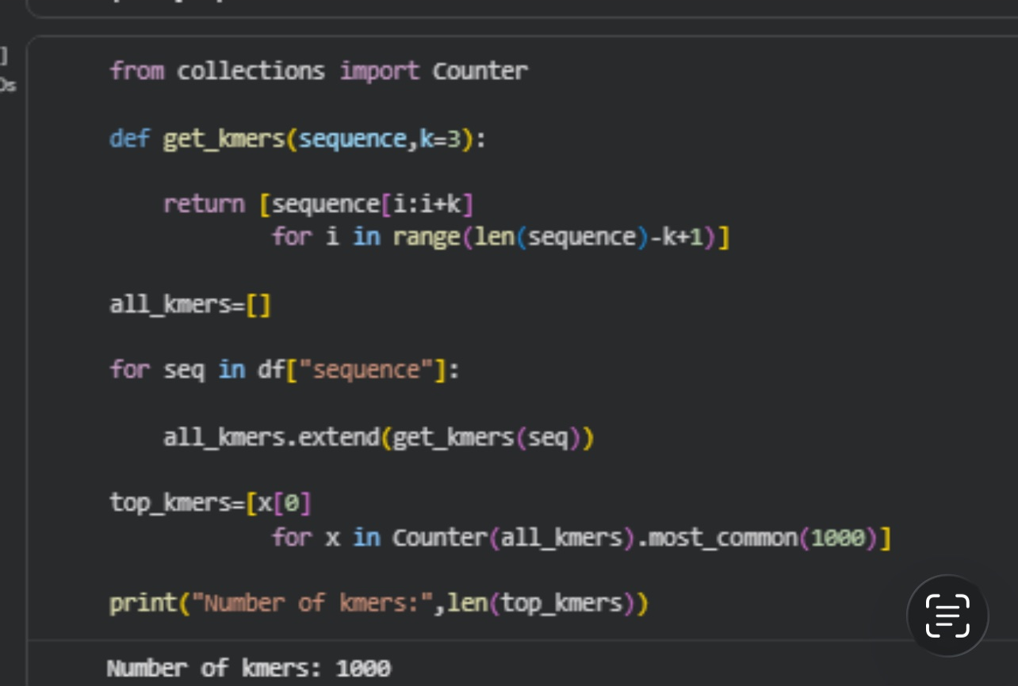
Fig. 1. k-mer (k=3) extraction — top 1,000 tri-mers selected.
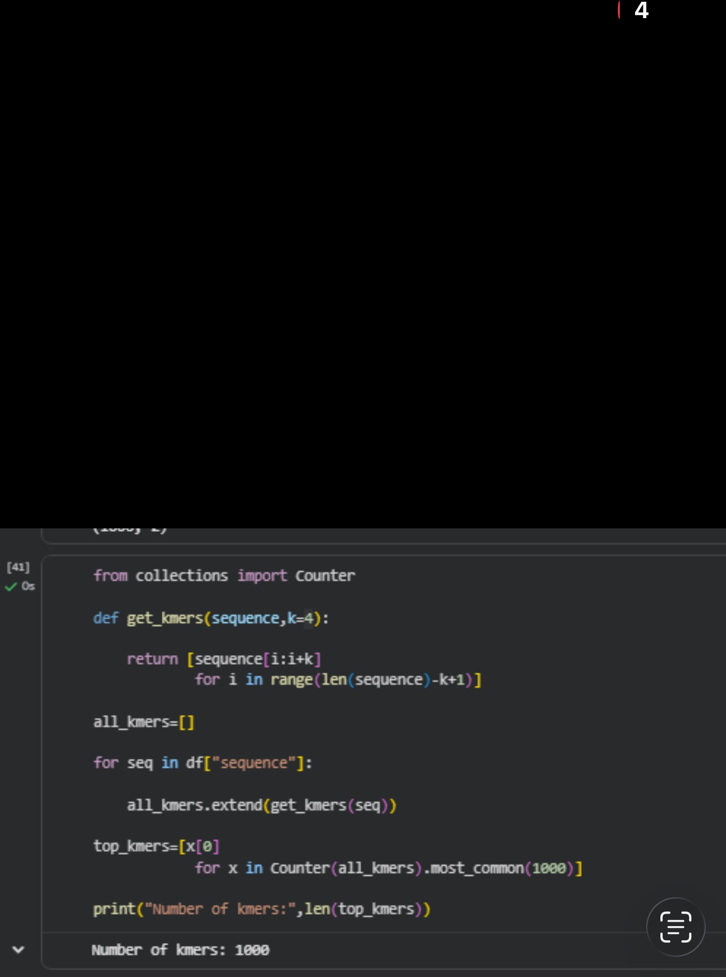
Fig. 2. k-mer (k=4) extraction — top 1,000 tetra-mers selected.
B. Random Forest Classifier (Student B)
A Random Forest (n_estimators=100) was trained independently on k=3 and k=4 feature matrices. Random Forests build multiple decision trees on bootstrapped subsets and aggregate by majority vote, offering robustness in high-dimensional sparse feature spaces.
C. BLAST Baseline (Student A)
Training sequences are exported to FASTA with label-embedded headers (>accession|label). NCBI BLAST+ constructs a protein database via makeblastdb (-dbtype prot). blastp is run with -outfmt 6, -max_target_seqs 1, and -evalue 0.001 for 1-nearest-neighbor classification. Queries with no significant hit are left unclassified.
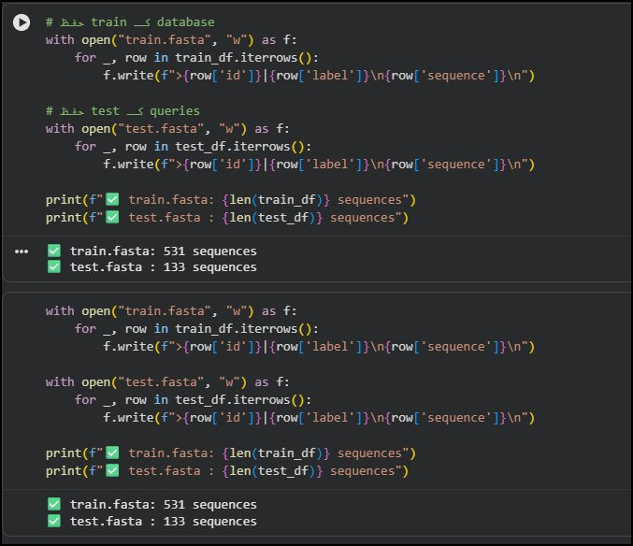
Fig. A3. FASTA export — 531 training sequences with label-embedded headers.
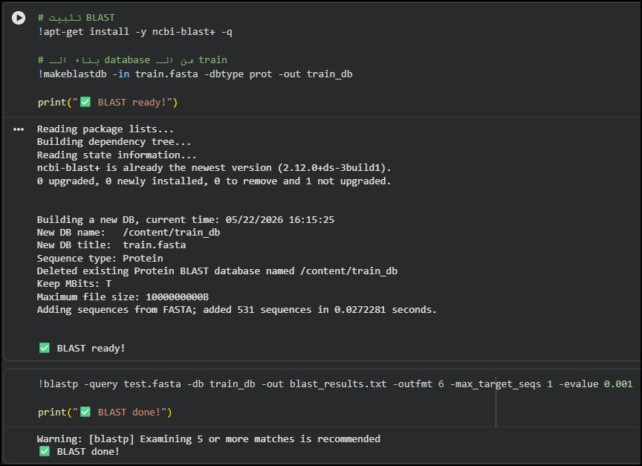
Fig. A4. BLAST database construction and blastp search.
IV. RESULTS
A. k-mer (k=3) + Random Forest
The k=3 model achieved 37.5% accuracy and macro F1 of 0.37. Transporters achieved the highest F1 (0.58); Kinases were the hardest class (F1=0.29).
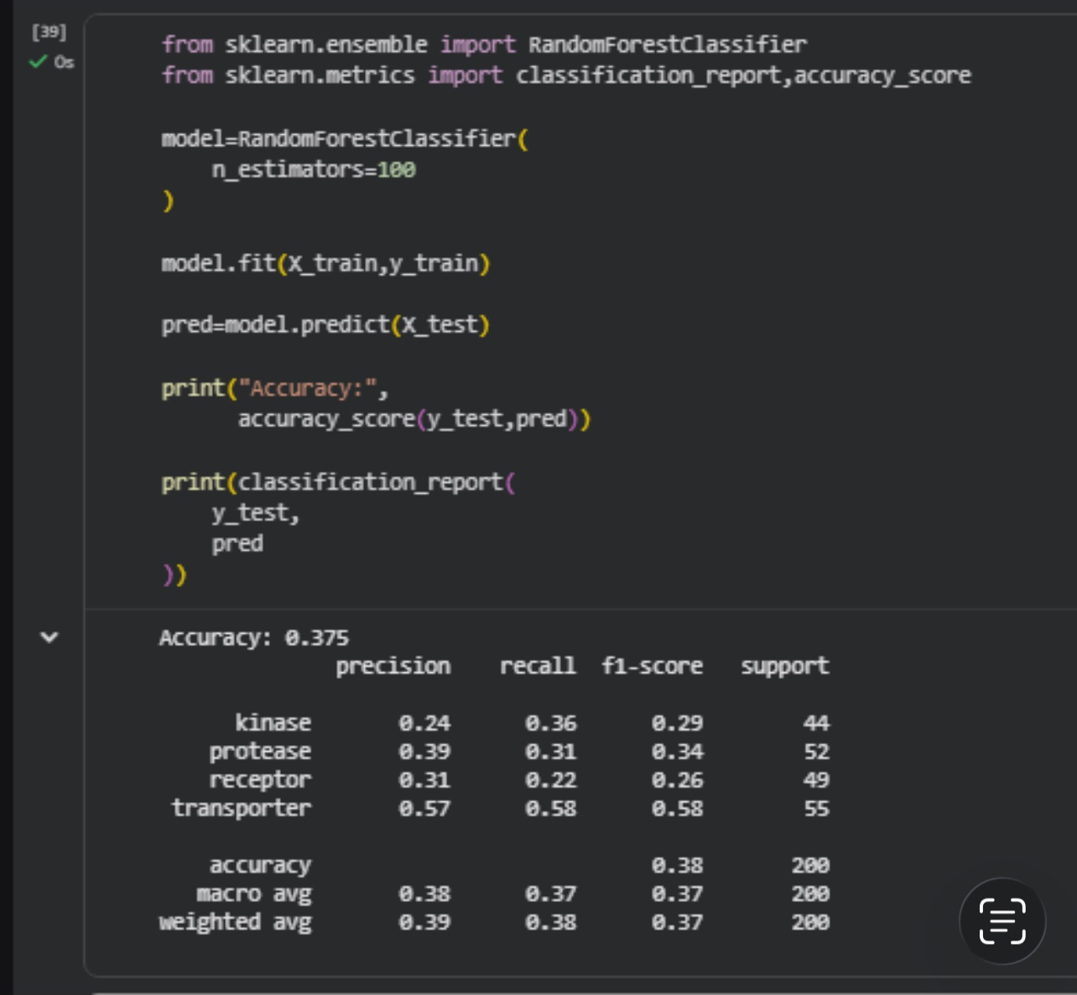
Fig. 3. k=3 RF classification report — Accuracy: 37.5%.
TABLE I. K-MER (K=3) + RF — CLASSIFICATION REPORT
Class | Prec. | Recall | F1 | Sup.
Kinase | 0.24 | 0.36 | 0.29 | 44
Protease | 0.39 | 0.31 | 0.34 | 52
Receptor | 0.31 | 0.22 | 0.26 | 49
Transporter | 0.57 | 0.58 | 0.58 | 55
Macro Avg | 0.38 | 0.37 | 0.37 | 200
Accuracy | — | — | 0.375 | 200
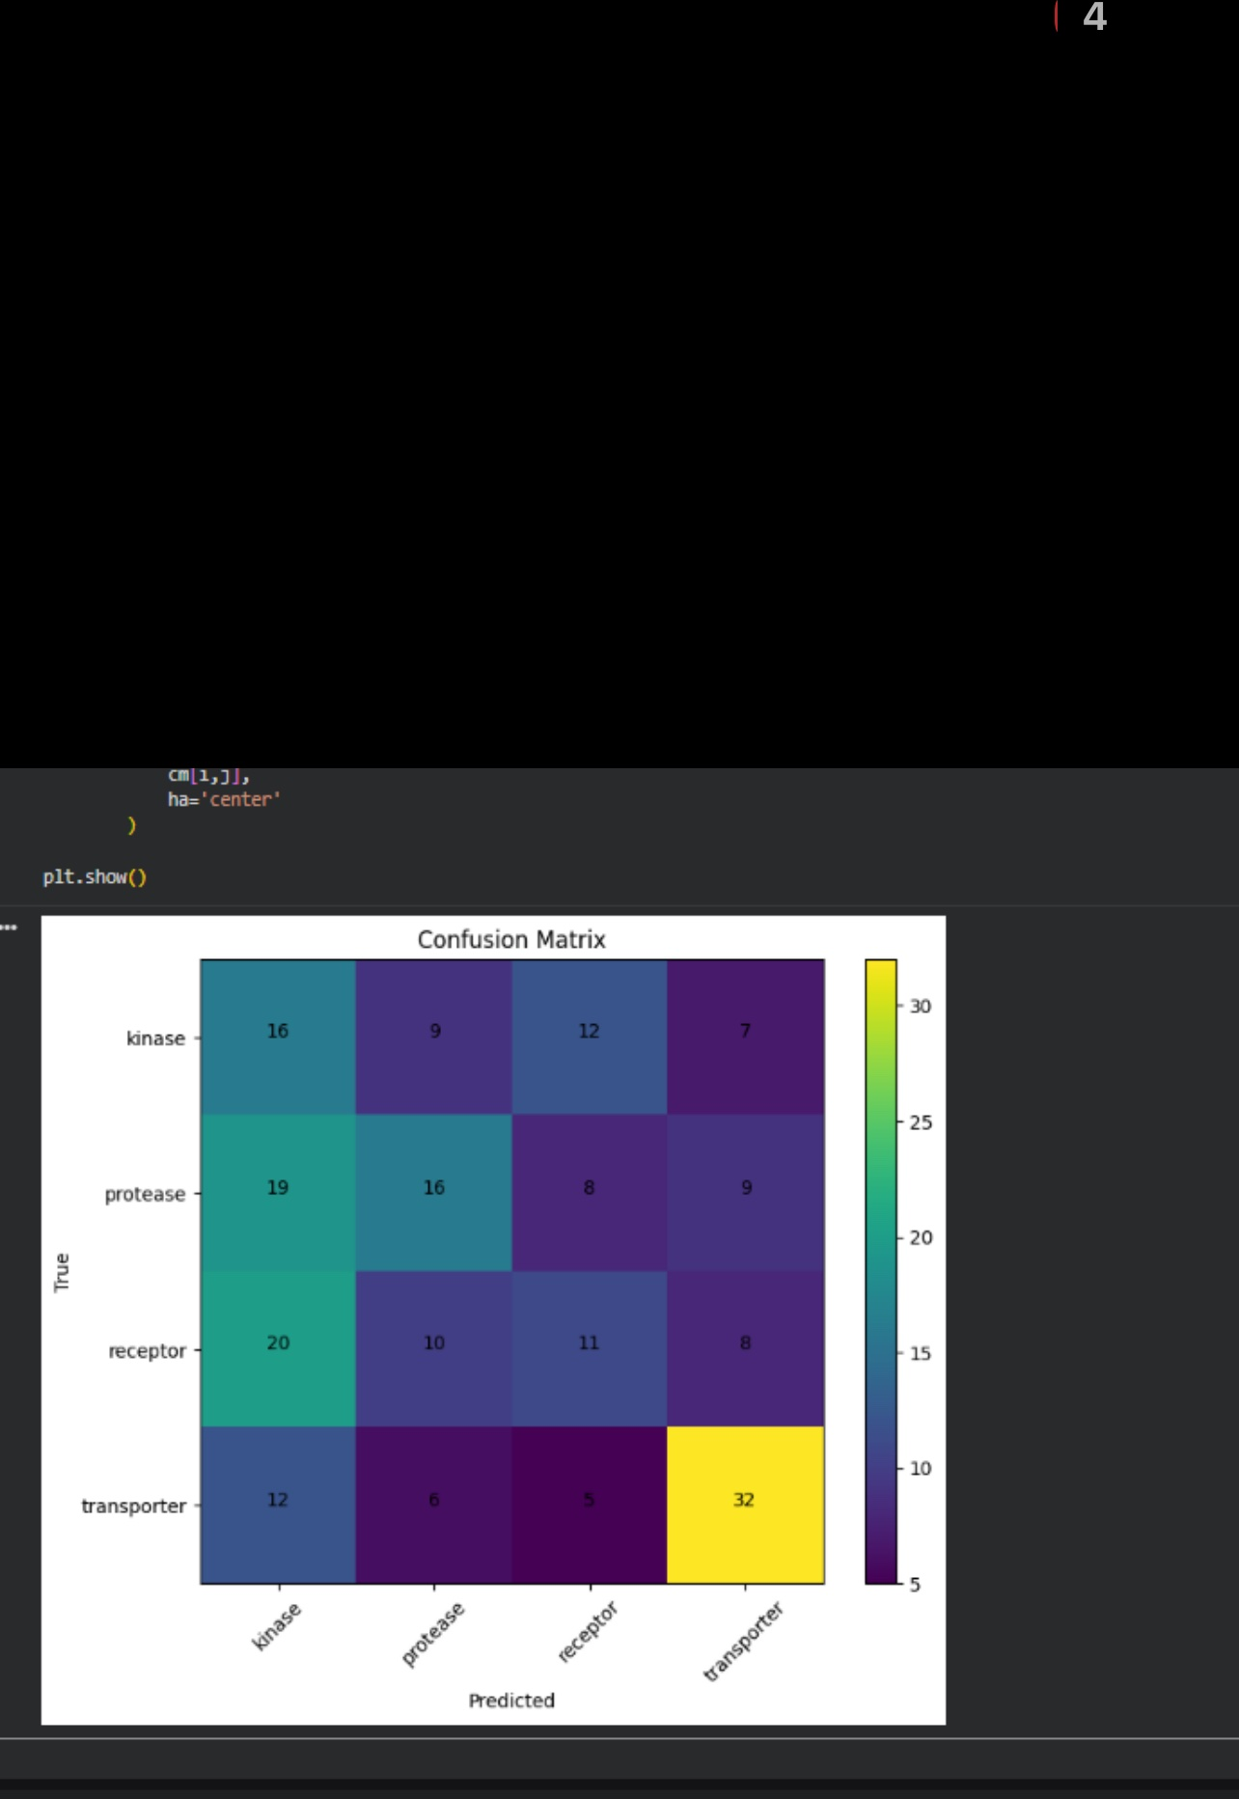
Fig. 4. Confusion matrix — k=3 RF. Transporter best (32/55 correct).
B. k-mer (k=4) + Random Forest
The k=4 model achieved 35.0% accuracy and macro F1 of 0.34. Protease recall improved to 0.44 (vs 0.31 for k=3); Receptor performance degraded (F1=0.23).
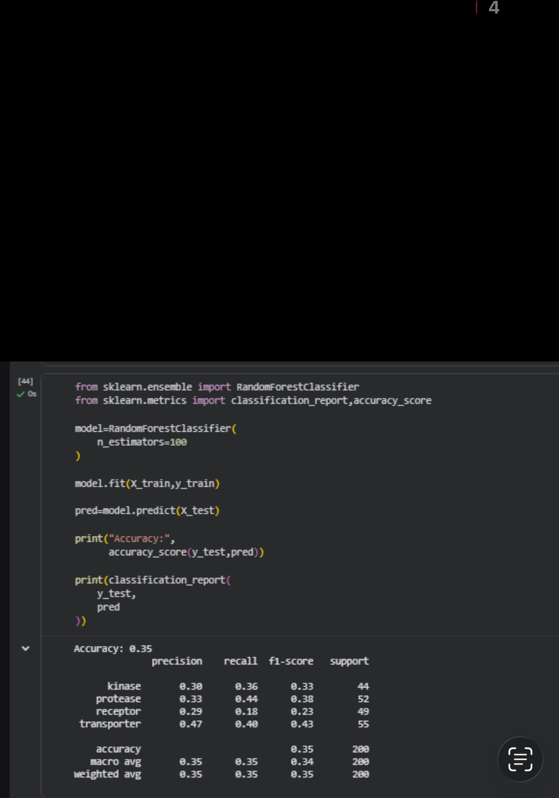
Fig. 5. k=4 RF classification report — Accuracy: 35.0%.
TABLE II. K-MER (K=4) + RF — CLASSIFICATION REPORT
Class | Prec. | Recall | F1 | Sup.
Kinase | 0.30 | 0.36 | 0.33 | 44
Protease | 0.33 | 0.44 | 0.38 | 52
Receptor | 0.29 | 0.18 | 0.23 | 49
Transporter | 0.47 | 0.40 | 0.43 | 55
Macro Avg | 0.35 | 0.35 | 0.34 | 200
Accuracy | — | — | 0.350 | 200
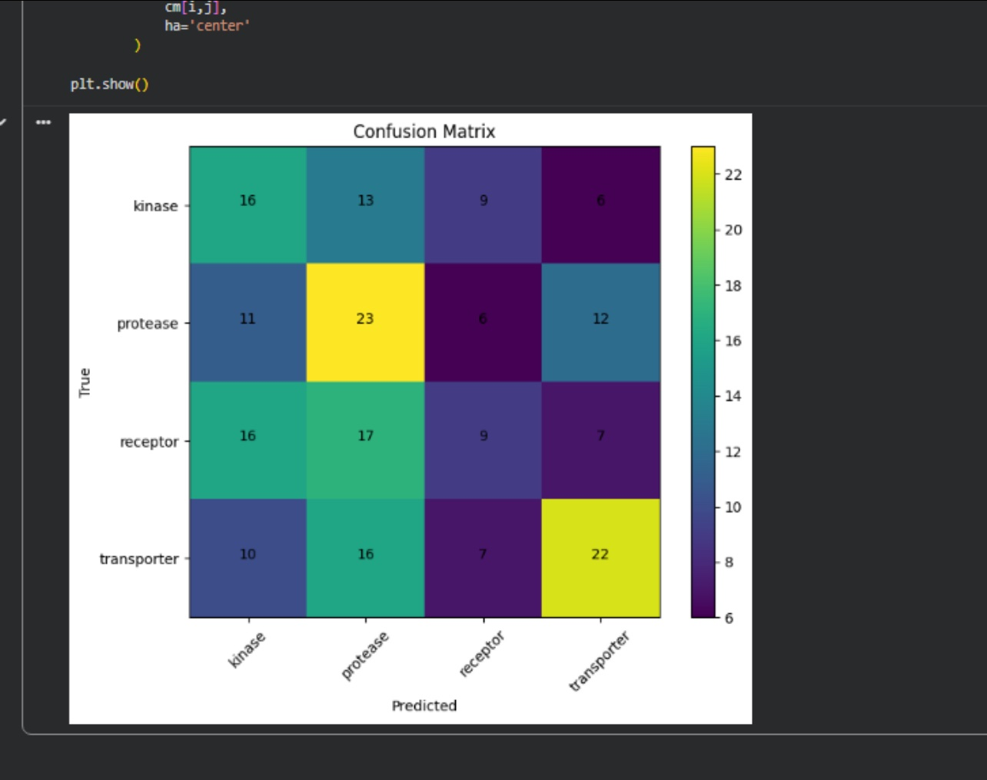
Fig. 6. Confusion matrix — k=4 RF. Protease diagonal improves (23/52).
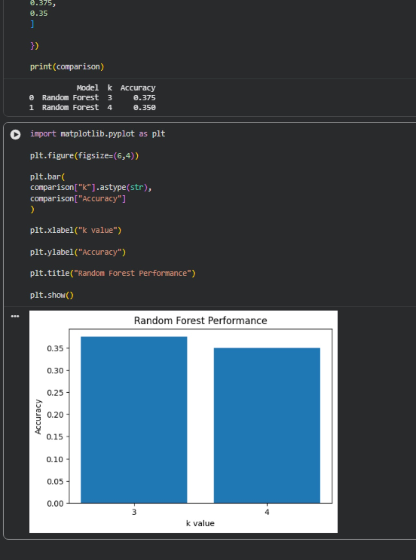
Fig. 7. RF accuracy comparison: k=3 (37.5%) vs. k=4 (35.0%).
C. BLAST Baseline (Student A)
BLAST found a significant hit (E ≤ 0.001) for 106 of 133 test sequences (79.7% match rate). On the matched subset: Accuracy 0.934, Precision (macro) 0.925, Recall (macro) 0.930. The 27 unmatched sequences represent proteins with low identity to any training example.
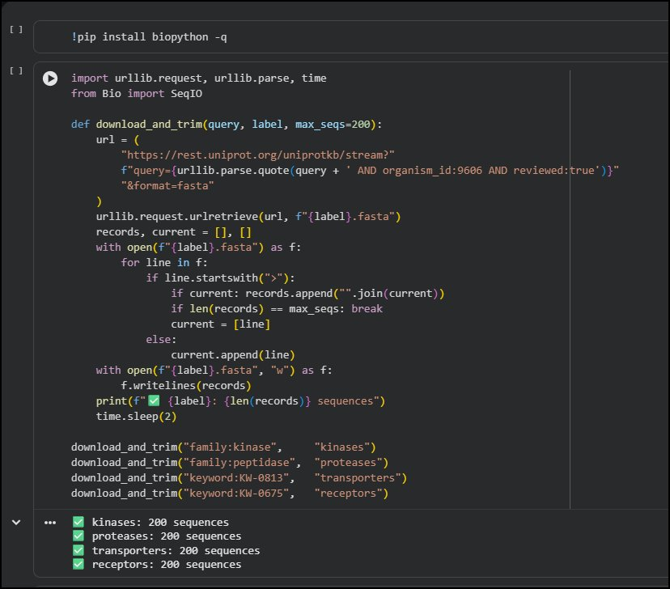
Fig. A1. UniProt data acquisition — 200 sequences per family downloaded.
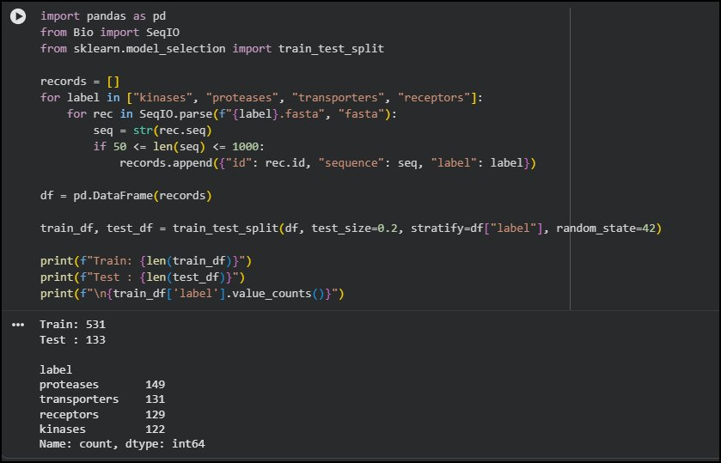
Fig. A2. Preprocessing and 80/20 stratified split — Train 531, Test 133.
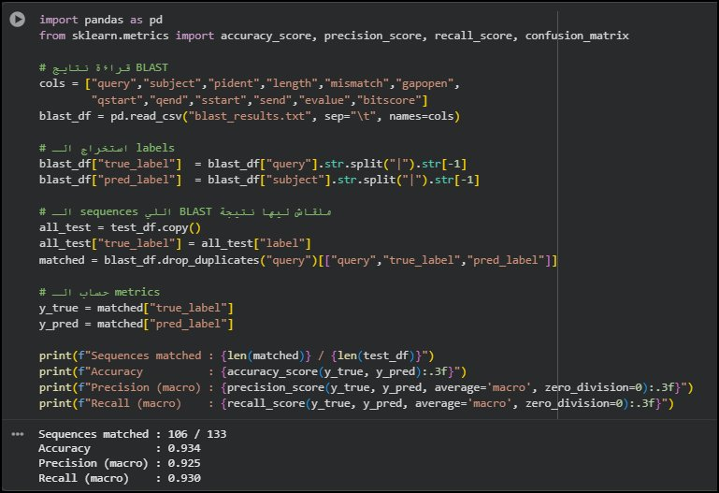
Fig. A5. BLAST evaluation — 106/133 matched; Accuracy 0.934.
D. Summary Comparison
TABLE III. SUMMARY — ALL MODELS
Model | Accuracy | Macro F1 | Best Class | Worst Class
k-mer k=3 + RF | 0.375 | 0.37 | Transporter | Kinase
k-mer k=4 + RF | 0.350 | 0.34 | Transporter | Receptor
BLAST (matched) | 0.934 | 0.93 | All classes | —
V. DISCUSSION
A. BLAST Dominance
The BLAST baseline (93.4% on matched sequences) substantially outperforms the k-mer ML models. The four target families possess conserved motifs — kinase P-loop, protease active-site triad, transporter transmembrane helices, receptor signaling domains — that BLAST reliably detects. However, BLAST leaves 20.3% of sequences unclassified, where k-mer features can provide a fallback.
B. k=3 vs. k=4
k=3 marginally outperforms k=4 (37.5% vs. 35.0%). The larger tetra-mer vocabulary (~160,000 possible vs ~8,000) means the top 1,000 features cover a smaller fraction of possible patterns. Additionally, tetra-mers are sparser per sequence, reducing the signal available to the classifier.
C. Transporter — Easiest Class
Transporters consistently achieved the highest F1 across both models (0.43–0.58) due to their distinctive hydrophobic transmembrane helices, which produce recognizable k-mer frequency signatures.
D. Kinase–Receptor Confusion
Both models show systematic confusion between Kinases and Receptors. This is biologically expected: receptor tyrosine kinases are simultaneously receptors and kinases, sharing catalytic domain patterns that overlap in k-mer feature space.
E. Hybrid Opportunity
A hybrid system using BLAST for high-confidence matches and the k-mer classifier as a fallback for unmatched sequences could combine the high precision of homology search with broader sequence coverage — a practical direction for future work.
VI. CONCLUSION
This project evaluated k-mer frequency + Random Forest (k=3: 37.5%, k=4: 35.0%) and BLAST (93.4% on matched sequences) for four-class protein family classification. Classical homology-based methods remain the most accurate in this regime. The k-mer approach provides meaningful classification above the 25% random baseline and offers coverage for novel sequences where BLAST fails. Future work should explore protein language model embeddings (ESM-2, ProtTrans) and a hybrid BLAST + ML fallback system.
REFERENCES
[1] S. F. Altschul et al., "Basic local alignment search tool," J. Mol. Biol., vol. 215, no. 3, pp. 403–410, 1990.
[2] L. Breiman, "Random forests," Mach. Learn., vol. 45, no. 1, pp. 5–32, 2001.
[3] UniProt Consortium, "UniProt: the universal protein knowledgebase in 2023," Nucleic Acids Res., vol. 51, no. D1, pp. D523–D531, 2023.
[4] A. Rives et al., "Biological structure and function emerge from scaling unsupervised learning to 250 million protein sequences," PNAS, vol. 118, no. 15, 2021.
[5] E. Asgari and M. R. K. Mofrad, "Continuous distributed representation of biological sequences," PLOS ONE, vol. 10, no. 11, 2015.
[6] S. B. Needleman and C. D. Wunsch, "A general method applicable to the search for similarities in the amino acid sequence of two proteins," J. Mol. Biol., vol. 48, no. 3, pp. 443–453, 1970.

